LIBRARY MANAGEMENT SYSTEM

SQL PROJECT REPORT

Name: Tanvi Manoj Bhavsar

Course: BSc IT

Subject: Database Management System

College: B.K Birla College Kalyan West

OBJECTIVE
The objective of this project is to manage library book records using SQL. It helps store and retrieve book information efficiently.

DESCRIPTION
The Library Management System is a simple database project developed using SQL. It stores details of books such as book ID, book name, author name and availability status. SQL queries are used to insert, retrieve, filter and sort records.

TOOL USED
1. SQL
2. DB Fiddle
3. Google Chrome

DATABASE SCHEMA

CREATE TABLE books (
Id INTEGER,
Name TEXT,
Author TEXT,
Status TEXT
);

SQL QUERIES

INSERT INTO books VALUES (1,’Python Basics’,’John’,’Available’);
INSERT INTO books VALUES (2,’SQL Guide’,’Mike’,’Issued’);
INSERT INTO books VALUES (3,’C++ Book’,’Alex’,’Available’);
SELECT * FROM books;
SELECT * FROM books WHERE status=’Available’;
SELECT * FROM books ORDER BY name;

OUTPUT
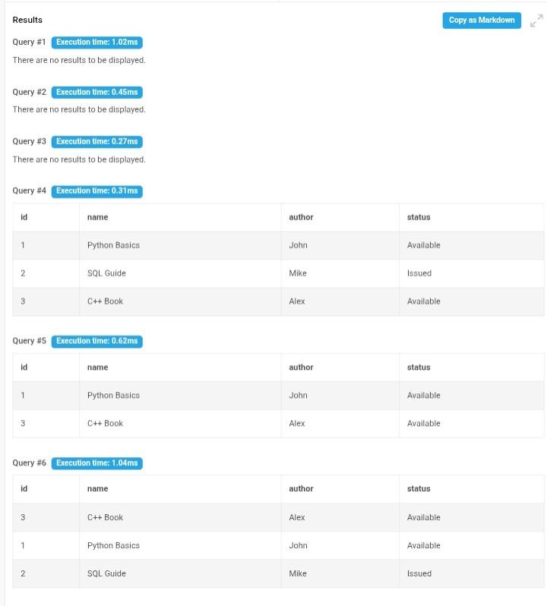

QUERIES EXPLANATION

• SELECT
Used to display all records from the table.

• WHERE
Used to filter records based on a condition.

• ORDER BY
Used to sort records in ascending order.

CONCLUSION

This project helped in understanding SQL database operations such as table creation, data insertion, data retrieval, filtering and sorting. It provides basic knowledge of database management systems.

